日高ダイキャスト工業株式会社

ＨＩＤＡＫＡ ＤＩＥCASTING INDUSTRY CO.,LTD.

FACTORY GUIDANCE

COMPANY PROFILE

- Company Name Hidaka Die Casting Industry
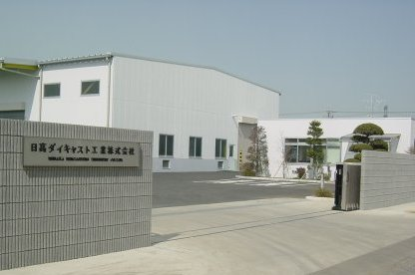

- Representative Ikuo Hata President
- Location 712 Asahigaoka Hidaka City
- Saitama Pref. Ｊａｐａｎ 350-1203
TEL 042-989-2411（Main）
FAX 042-985-3299
E-mail： info@hidakadc.co.jp
URL： http://www.hidakadc.co.jp/
- Plant/size 13,968㎡
- Building Area 4,443㎡
- Established Date August 19, 1965
- Capital JPY10,000,000
- Annual Sales JPY 150,000,000
- Number of Employees 75
- Production Volume 220Ton per Month
- Main Products Parts for General purpose engine ・Parts for Truck Engines and Other Parts . Machining and Manufacturing Aluminum Die Cast Products.

- Company History

August 1965 | The Chiyoda Casting Co., Ltd is founder Die Casting Division in Hidaka.
May 1985 | Factory №1 Expansion.
December 1989 | Expansion of the Product Warehouse and Office Building
September 1994 | Introduction of 650 ton Could Chamber Machine （Vertical）
May 2000 | Introduction of 330 ton Could Chamber Machine （Horizontal）
October 2000 | Introduction of 135 ton Could Chamber Machine （Horizontal）
June 2001 | Introduction of 350 ton Could Chamber Machine （Horizontal）
April 2002 | Introduction of Drilling Machine
July 2002 | Introduction of 350 ton Multi Injection Machine （Horizontal）
December 2002 | Purchase Adjacent Areas（1,157㎡ ）
March 2003 | Introduction of 350 ton Multi Injection Machine （Horizontal）
September 2003 | Introduction NC Lathe.
September 2003 | Introduction of 150 ton Multi Injection Machine （Horizontal）
January 2004 | Introduction of 350 ton Could Chamber Machine （Horizontal）
December 2004 | Completed the First New Plant and Office building
January 2005 | Introduction of 250 ton Multi Injection Machine （Horizontal）
January 2006 | Completed the second New Plant
February 2006 | Introduction of 800 ton Multi Injection Machine （Horizontal）
September 2007 | Introduction The second of 800 ton Multi Injection Machine （Horizontal）
January 2009 | Introduction of 350 ton Multi Injection Machine （Horizontal）
January 2009 | Introduction of №40 Machining Center Vertical type

An Associated Company

- Company Name CHIYODA CASTING Co. Ltd
チ代田鋳造株式会社
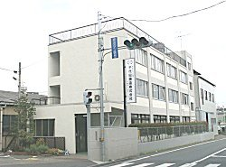

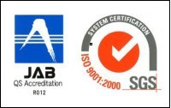

（ISO9001：2000 認証取得）

- Representative Ikuo Hata President

- Location 320 Chikumazawa MiyoshiTown Iruma District Saitama Pref. Japan 354-0043
Plant Area ４７５７㎡ Building Area ３０８７㎡
ＴＥＬ 049-258-2811 ＦＡＸ 049-258-0619

- Established Date October ,1928

- Capital JPY 10,000,000 ●Annual Sales JPY１30,000,000 ● Number of Employees 70

- Main Products : Parts for Truck Engines ・ Parts of Fire-Fighting Pump ・ Parts of Outboard Motors ・ Parts for General purpose engine ・ Cabinet for Electronic Parts ・ Parts for Servo Motors ・ Parts of Radar ・Aluminum Sand Mold Casting Parts.

- Equipment
Ｆ1 Jolt Squeeze machine | 3 | ＫＳ11 Turn Over | 1
FBMHorizontalParting Flaskless Molding Machine | １ | ＡＰＳStatic Pressure Molding Machine | 1
Furan Self Hardening Property Line | 2 | Optical Emission Spectrometer | 1
３D ＣＡＤ／ＣＡＭ | 2 | Machining Center | 1

Factory Equipment

- Equipment List:

Equipment Name | Manufacturer | Number of Machines
150Ton Multi Injection Machine （Horizontal） | Toshiba Machine | 1
250Ton Multi Injection Machine （Horizontal） | Toshiba Machine | 2
250Ton Could Chamber Machine （Vertical） | Toshiba Machine | 2
350Ton Multi Injection Machine （Horizontal） | Toshiba Machine | 4
350Ton Could Chamber Machine （Horizontal） | Toshiba Machine | 3
５００Ton Could Chamber Machine（Vertical） | Toshiba Machine | 1
６５０Ton Could Chamber Machine（Vertical） | Toshiba Machine | １
８００Ton Could Chamber Machine（Horizontal） | Toshiba Machine | ２
Fanuc RoboDrill | Fanuc | １
Tapping Center | Brother | １
ＮC Lathe | Takizawa | ４
№40 Machining Center Vertical type | Yamazaki Mazak | １
Shot Blasting Machine | Sinto Brator | ３
3D Coordinate Measuring Machine | Mitutoyo | 1
3D Coordinate Measuring Machine | Tokio Precision | 1

- Toshiba 650Ton Die Casting Machine ■ Toshiba ３５０Ton
Multi Injection Machine

- Shot Blasting ■３D Measuring Machine
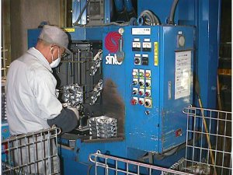
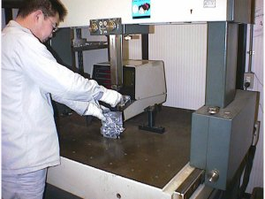

Ｆｅａｔｕｒｅｓ of ｔｈｅ Ｃｏｍｐａｎｙ
We are ready to own a horizontal multi-injection machine, meet all needs。

Toshiba 800Ton

- Features of the Horizontal multi-injection machine

Multi Injection Mechanism
Slow speed 0.05m/sec from (very slow), injection speed of machine is selected to 10m/sec (Ultra High-Speed​​)
Selection Possible, broad speed range unprecedented became possible.

Effect of high-speed injection on the microstructure of the ultra-high-speed
The ultrafast injection, by which to shorten the filling time into the cavity of the melt and compress sufficiently nest
I will contribute to the stabilization and improvement of the internal quality of the product.
In addition, by coagulation or pieces nest entrainment is fine diffusion, the uniformity of the organization
Until it is possible to achieve stabilization of confidentiality and mechanical strength of the product can be expected.

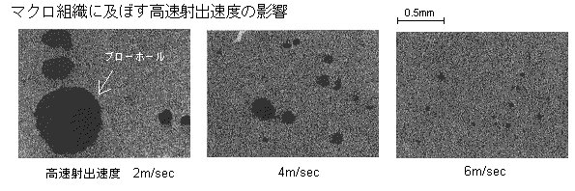
High injection speed on the macrostructure Influence

High Speed Injection
Effect of the Product
For injecting at a very high speed, production of thin-walled precision products becomes easy.
In addition, since the nest entrainment inside the product is fine diffusion, a product with excellent pressure resistance and strength possible.

Main Products
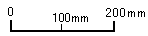
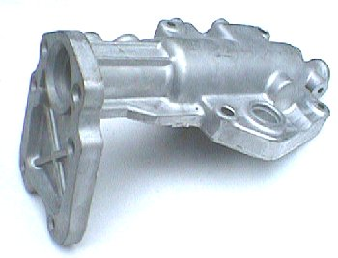
Housing Shift Lever (1.7Kg)

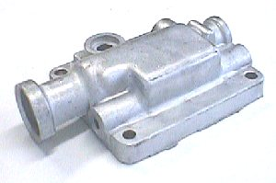
Housing Shift Lever (0.7Kg)
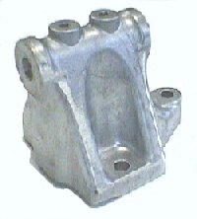
Generator
Bracket
(0.7Kg)
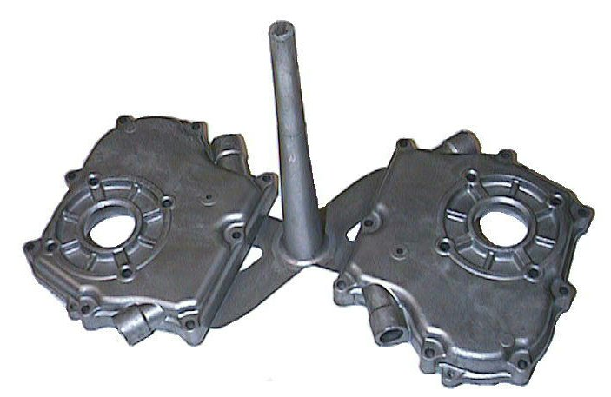
Main Bearing Cover 2Cavity With Runner Gate
（０．５Ｋｇ）
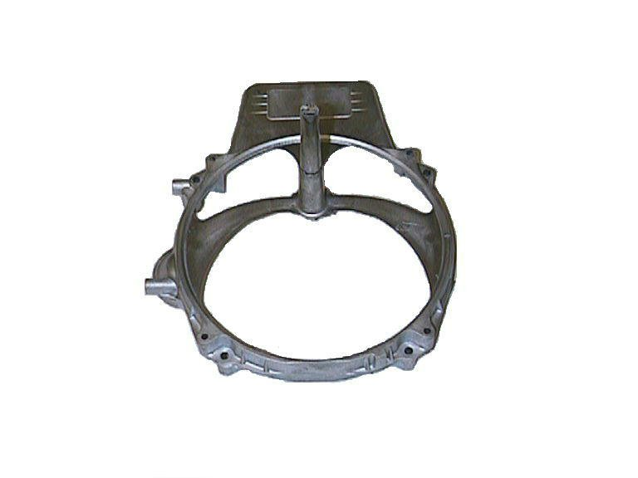
Blower Housing With Runner Gate
（０．８Ｋｇ）
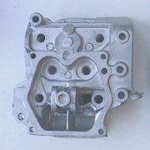
Cylinder Head
（２．０Ｋｇ）
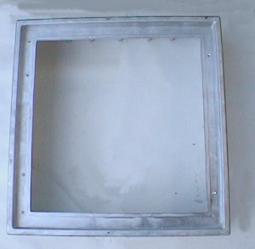
Street Light Cover
（５Ｋｇ）
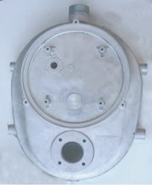
Flow Meter Cover
（２．５Ｋｇ）

Main Customers
Customers | Fuji Heavy Industries Ltd. Saitama Factory
Customers | Hino Motors Ltd.
Customers | Valeo Thermal System Co.,Ltd.
Customers | SMC Corporation
Customers | Tokio Keiso Co.,Ltd.
Customers | Komatsu Ltd.
Customers | And Others Company
Main Banks

Saitama Resona Bank Niiza Branch Japan Finance Corporation
Musashino Bank Mizuhodai Branch Gunma Bank Kawagoe Branch
Accsess

- 7 minutes by taxi from Kawagoe Line Musashi Takahagi station
- 10 minutes from Kanetsu Highway Tsurugashima Interchange
- 5 minutes from Ken-o road Highway Ken-oTsurugashima Interchange
HIDAKA FACTORY 712 Asahigaoka
Roud 407
KEN-O TSURUGASHIMA INTERCHANGE
KANETSU SPEEDWAY TSURUGASHIMA INTERCHANGE
Kawagoe Line Musashi Takahagi Estation
